**Create a virtual network and an Azure Bastion host**

1. In the portal, search for and select **Virtual networks**.

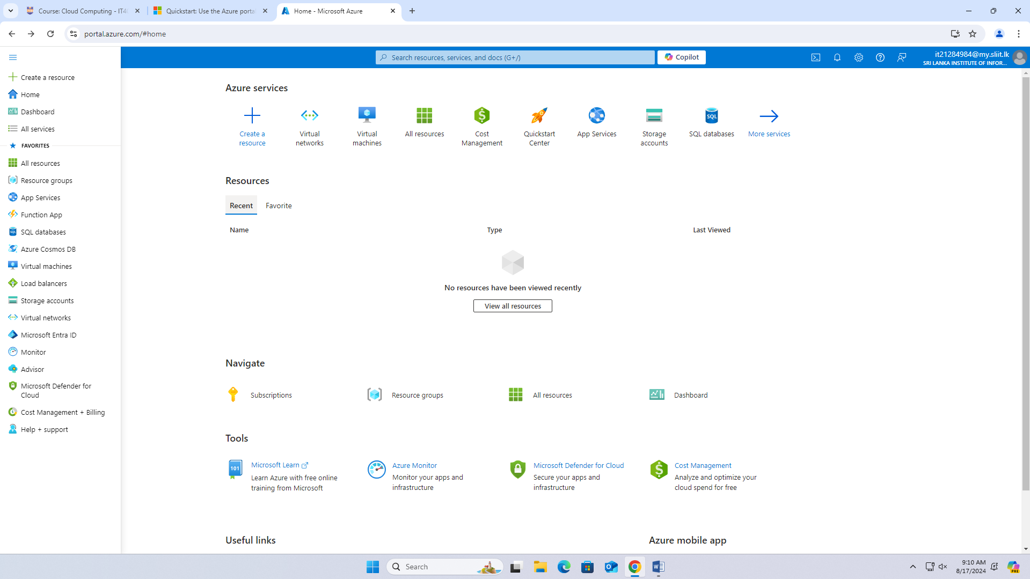

1. On the **Virtual networks** page, select **+ Create**.
2. On the **Basics** tab of **Create virtual network**, enter, or select the following information:

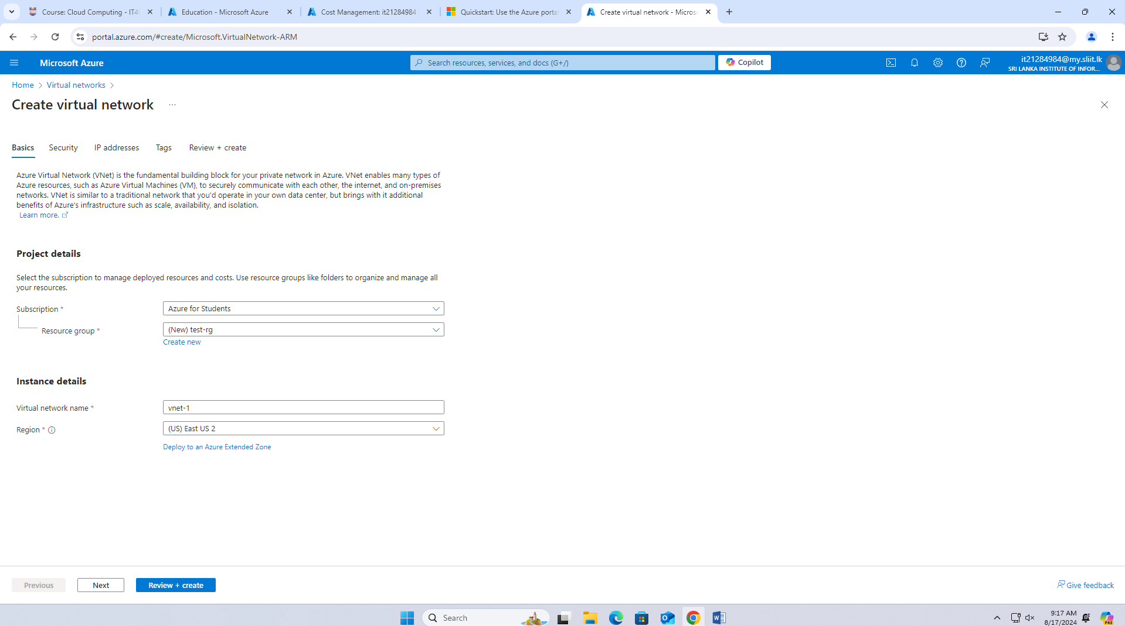

1. Select **Next** to proceed to the **Security** tab.
2. In the **Azure Bastion** section, select **Enable Azure Bastion**.

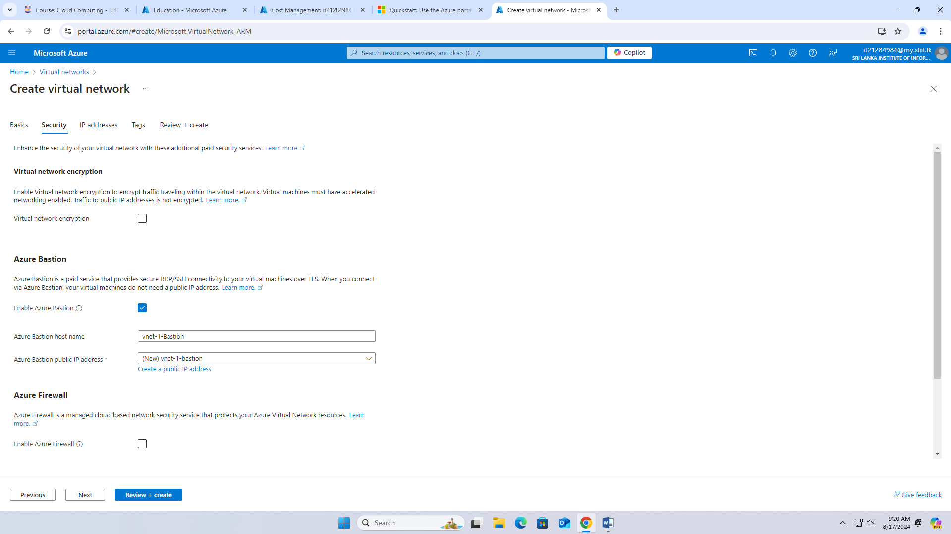

1. Select **Next** to proceed to the **IP Addresses** tab.
2. In the address space box in **Subnets**, select the **default** subnet.
3. In **Edit subnet**, enter or select the following information:

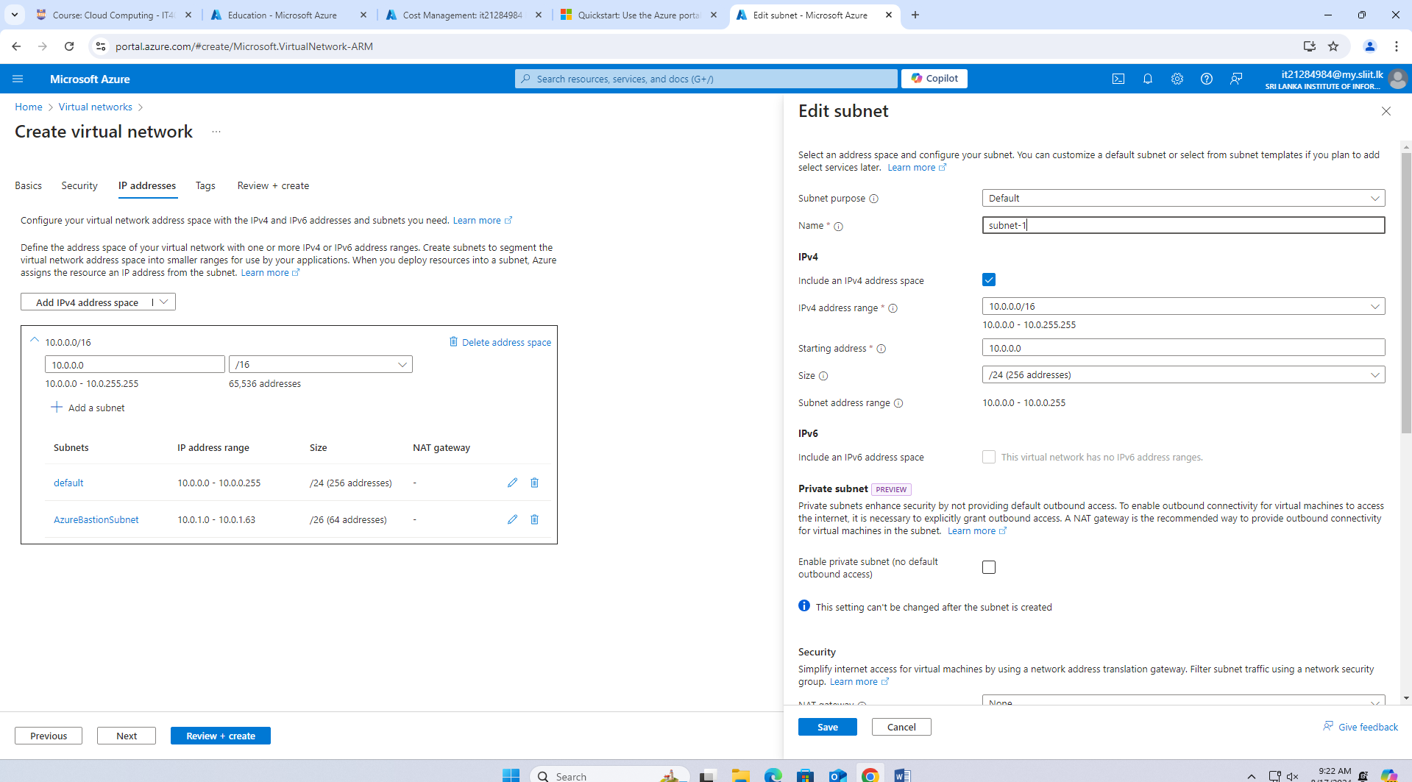

1. Select **Save**.
2. Select **Review + create** at the bottom of the window. When validation passes, select **Create**.

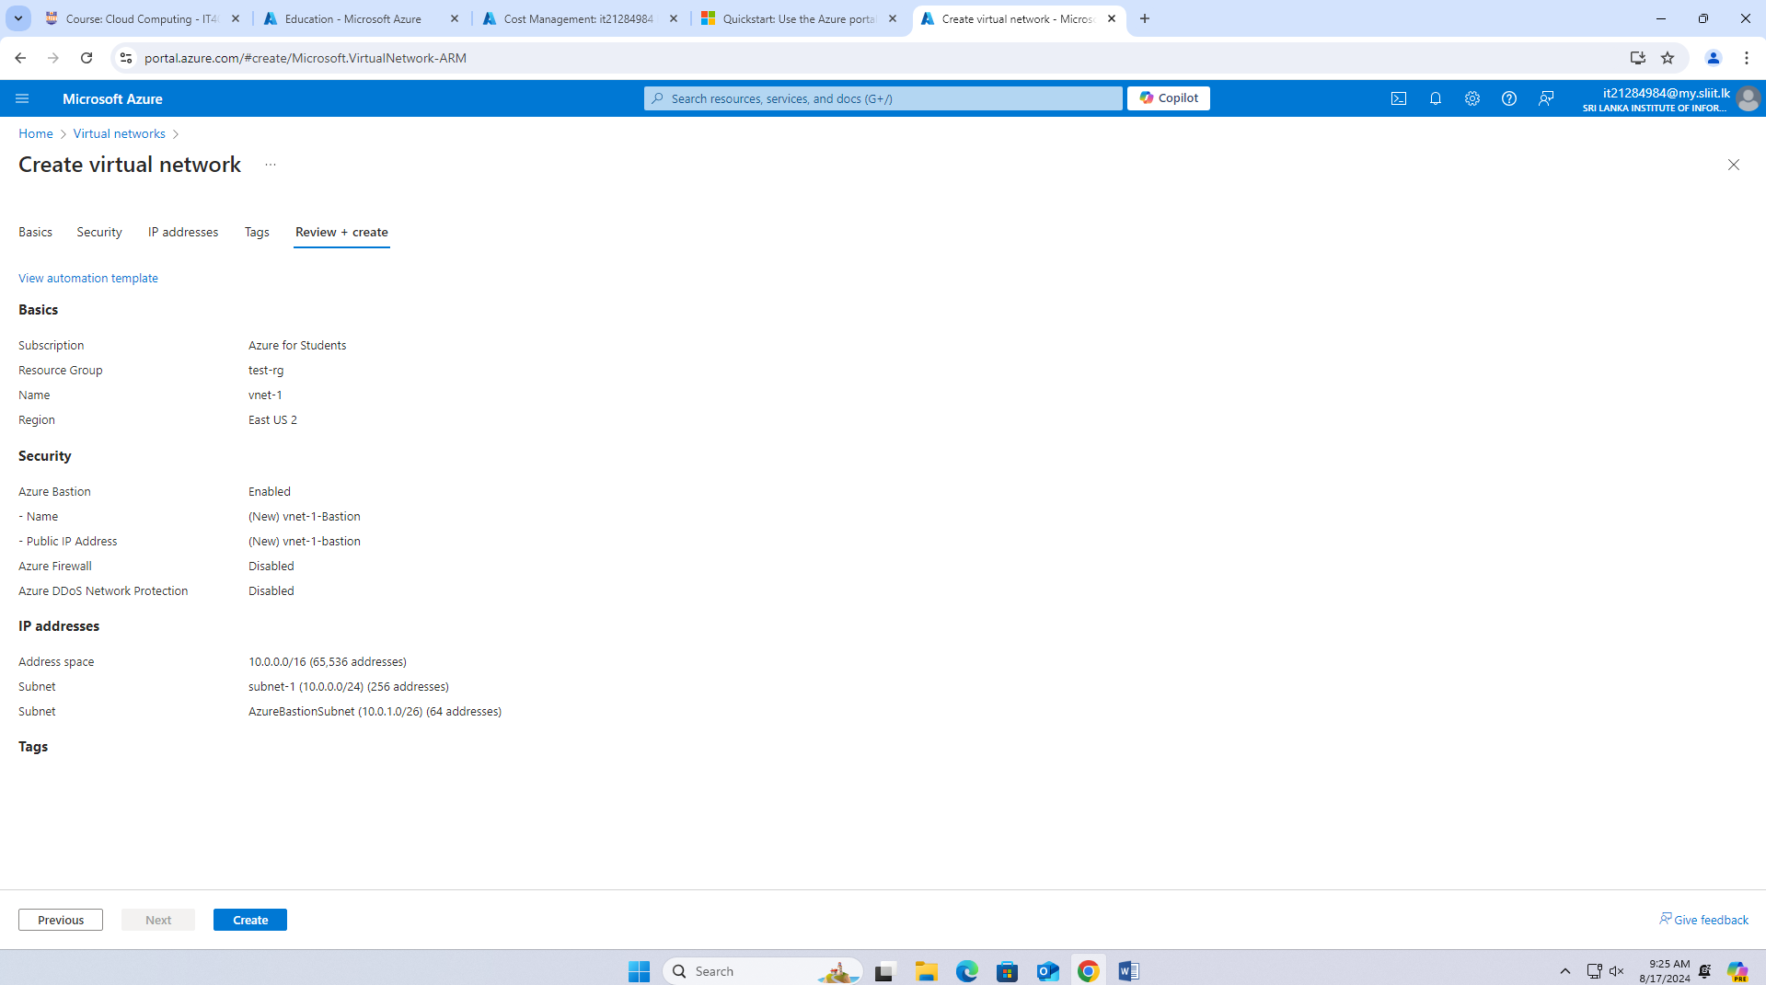

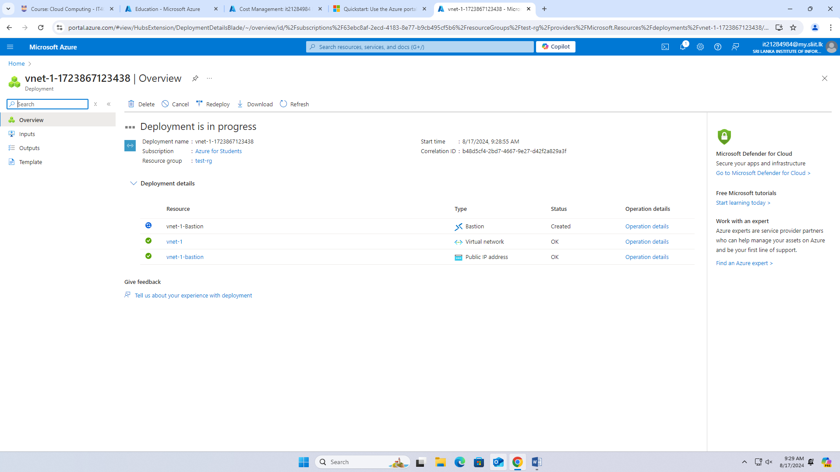

## Create virtual machines

1. In the portal, search for and select **Virtual machines**.
2. In **Virtual machines**, select **+ Create**, and then select **Azure virtual machine**.
3. On the **Basics** tab of **Create a virtual machine**, enter or select the following information:

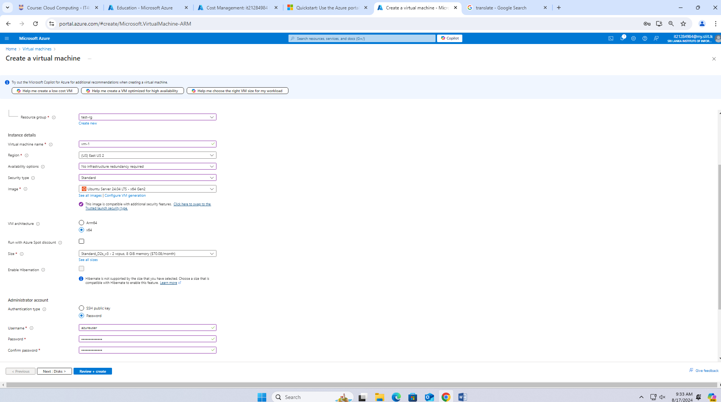

1. Select the **Networking** tab. Enter or select the following information:

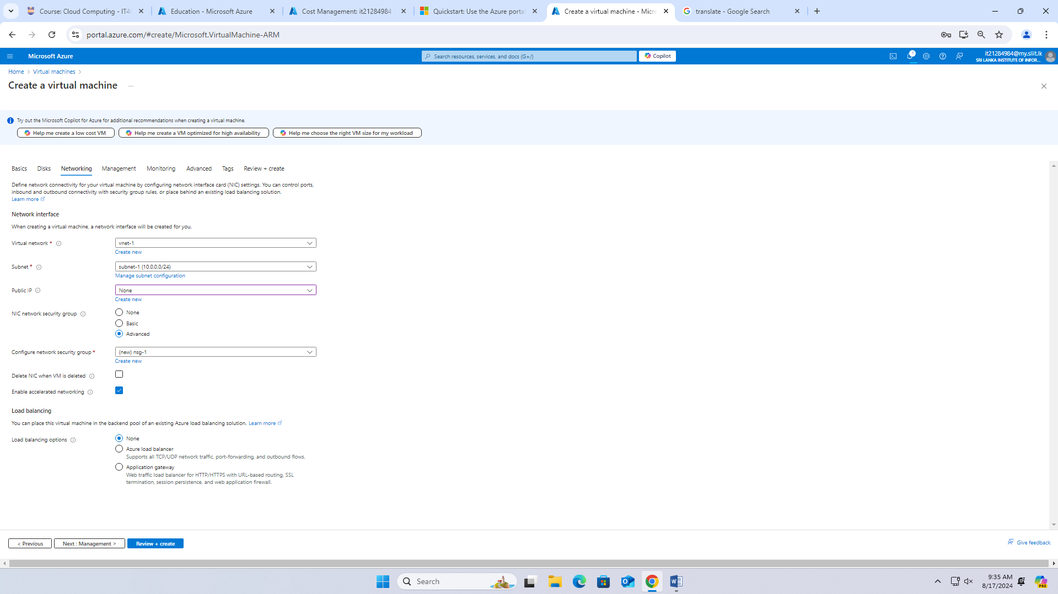

1. Leave the rest of the settings at the defaults and select **Review + create**.
2. Review the settings and select **Create**.

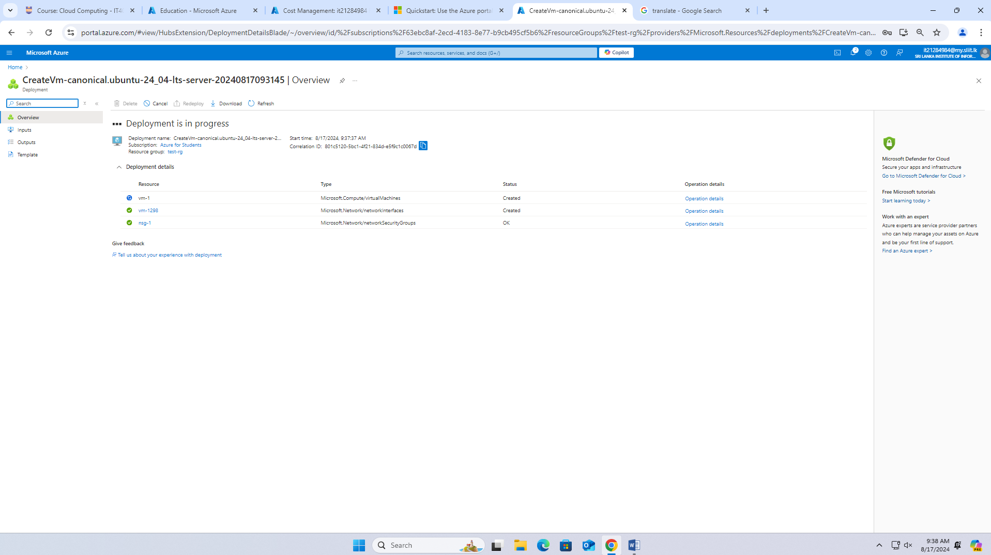  
  
**Create SECOND VM**

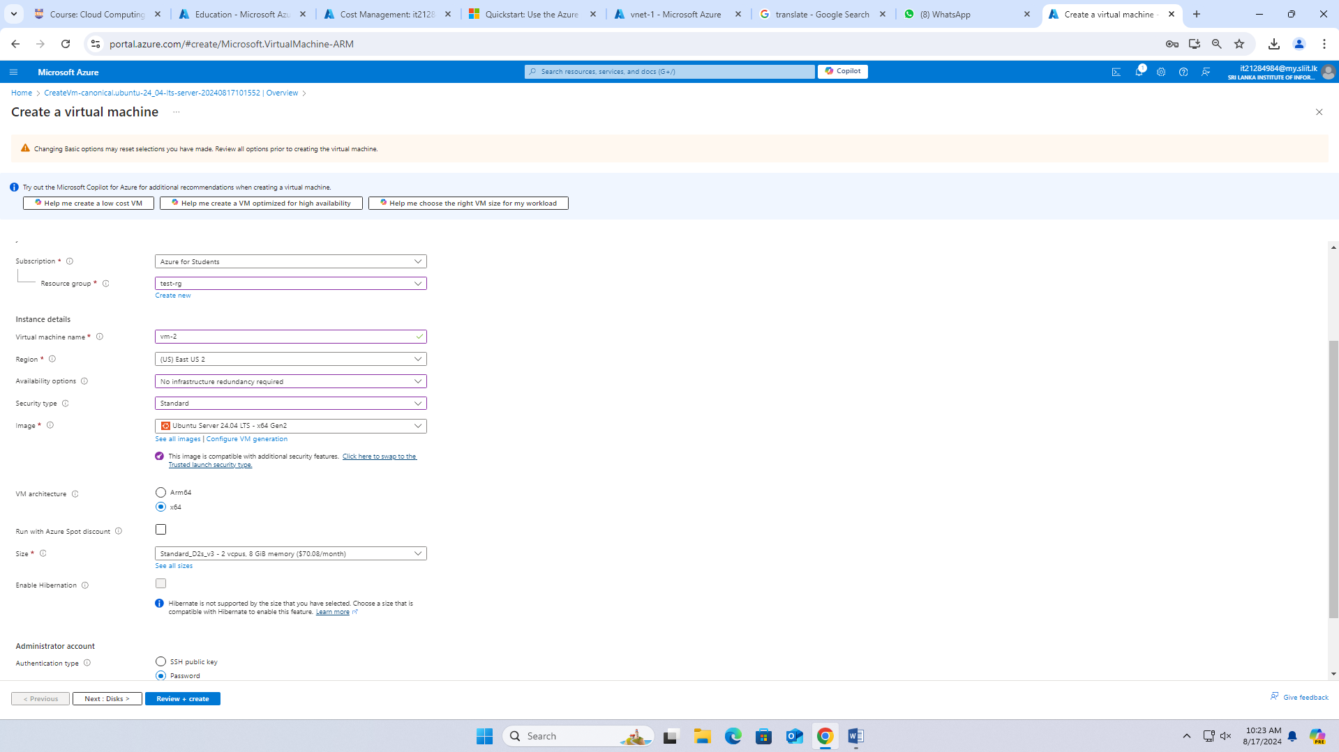

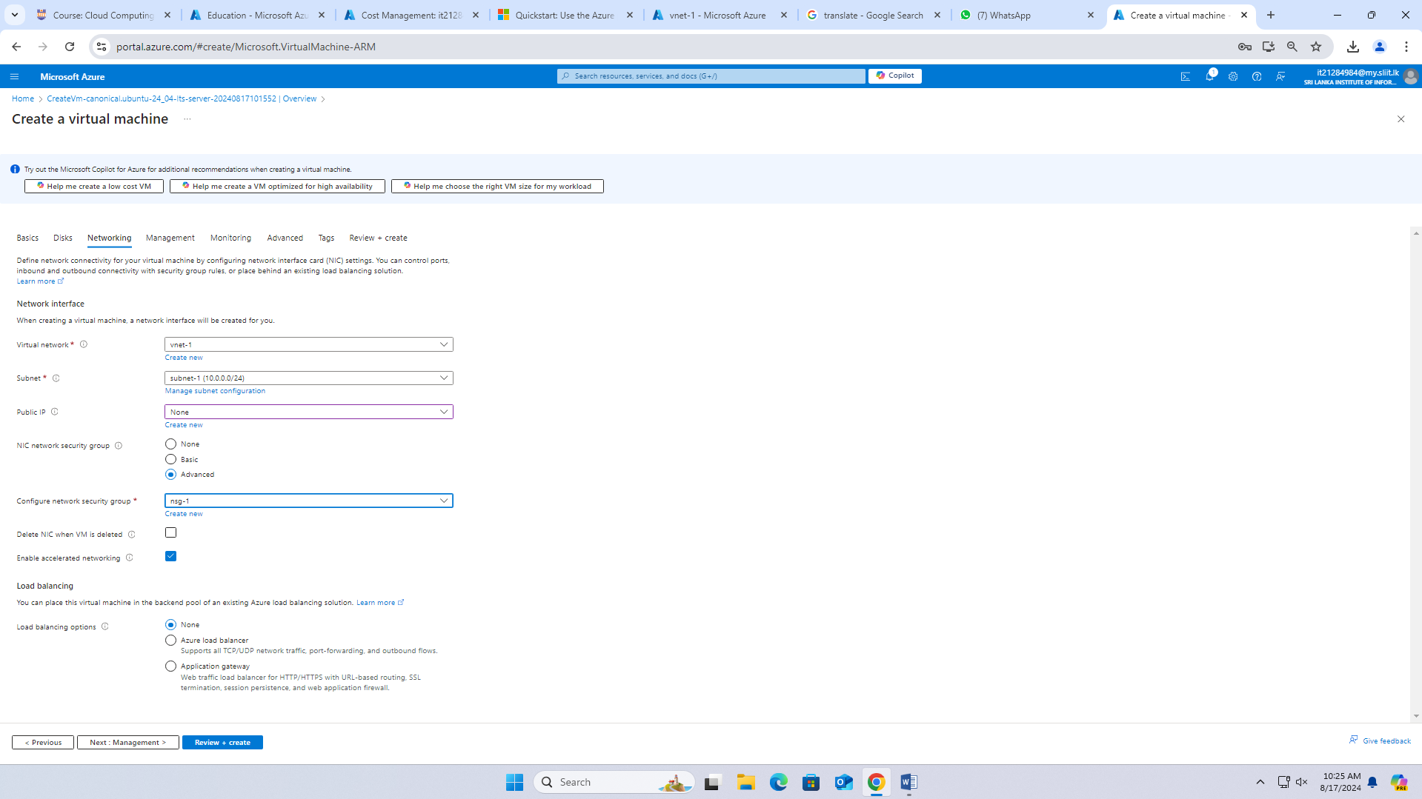

## Connect to a virtual machine 1

1. In the portal, search for and select **Virtual machines**.
2. On the **Virtual machines** page, select **vm-1**.
3. In the **Overview** information for **vm-1**, select **Connect**.
4. On the **Connect to virtual machine** page, select the **Bastion** tab.
5. Select **Use Bastion**.
6. Enter the username and password that you created when you created the VM, and then select **Connect**.

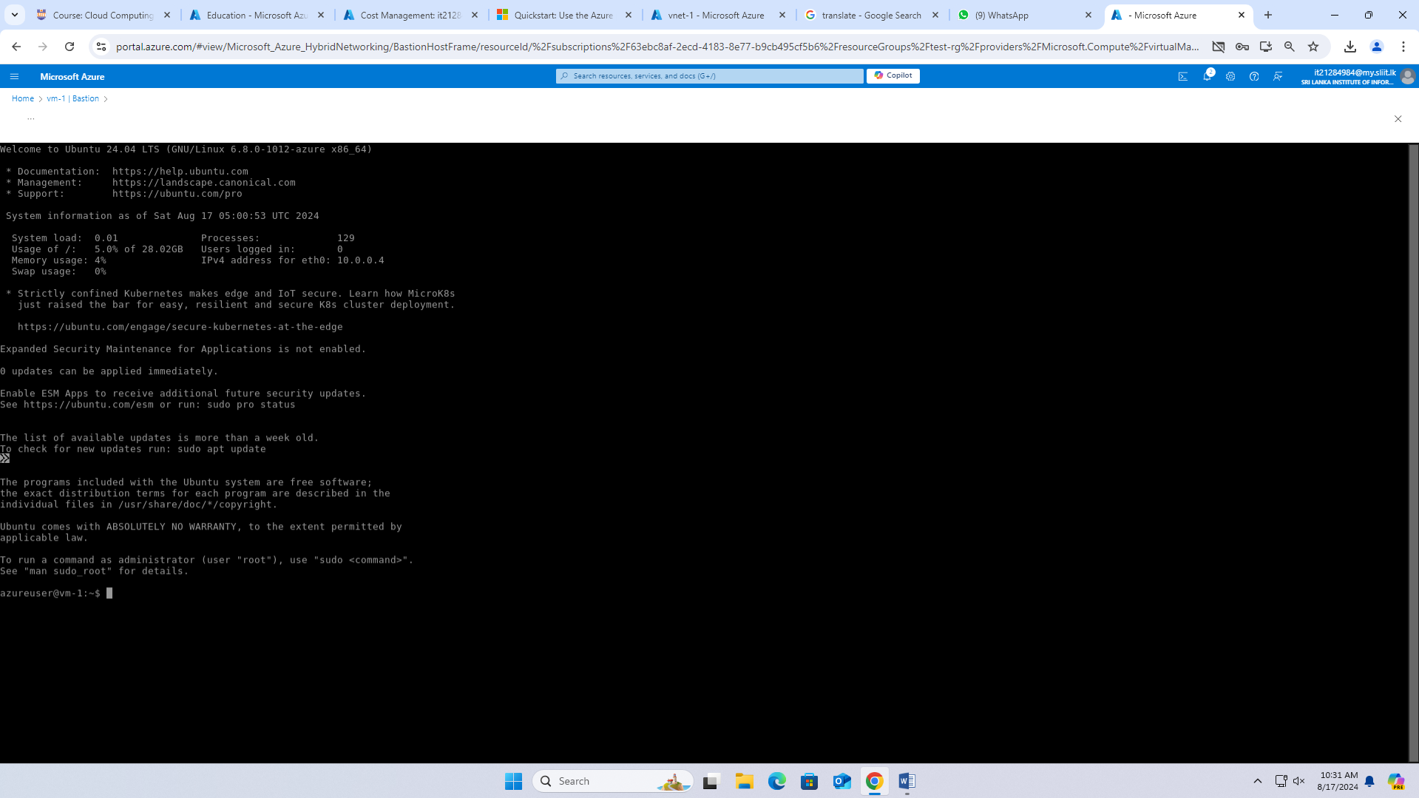

## Start communication between VMs

1. At the bash prompt for **vm-1**, enter ping -c 4 vm-2.

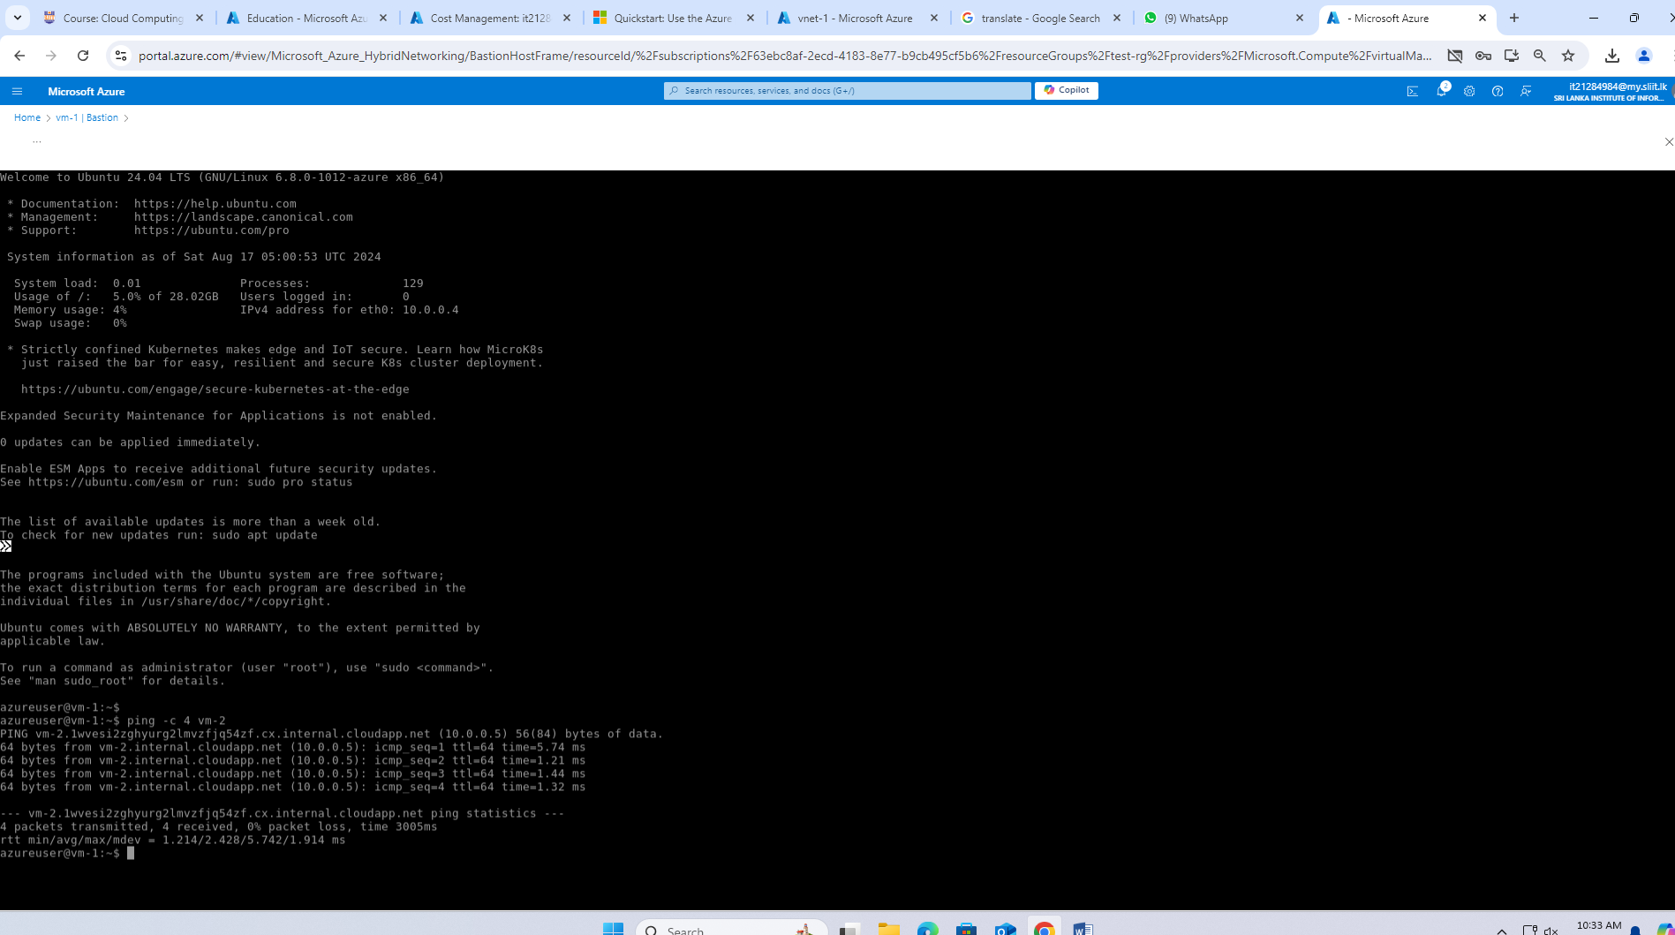

1. Close the Bastion connection to **vm-1**.

## Connect to a virtual machine 2

1. In the portal, search for and select **Virtual machines**.
2. On the **Virtual machines** page, select **vm-2**.
3. In the **Overview** information for **vm-2**, select **Connect**.
4. On the **Connect to virtual machine** page, select the **Bastion** tab.
5. Select **Use Bastion**.
6. Enter the username and password that you created when you created the VM, and then select **Connect**.

## Start communication between VMs

1. At the bash prompt for **vm-2**, enter ping -c 4 vm-1.

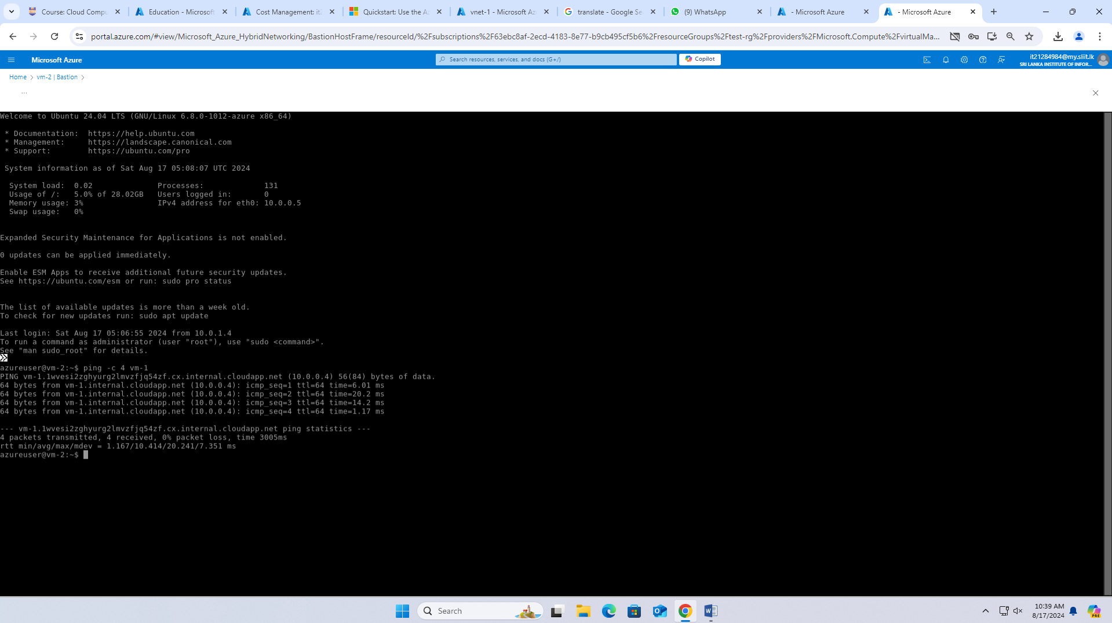

1. Close the Bastion connection to **vm-2**.

## Clean up resources

When you finish using the resources that you created, you can delete the resource group and all its resources:

1. In the Azure portal, search for and select **Resource groups**.
2. On the **Resource groups** page, select the **test-rg** resource group.
3. On the **test-rg** page, select **Delete resource group**.
4. Enter **test-rg** in **Enter resource group name to confirm deletion**, and then select **Delete**.

